**Práctica 2 – Repaso de redes – Enrutamiento IP**

Dada la siguiente red, pon las direcciones IP que creas oportunas de la red 172.16.0.0 haciendo subnetting, es decir, los primeros 16 bits deben ser 172.16 (NO PUEDES USAR LA MASCARA POR DEFECTO).

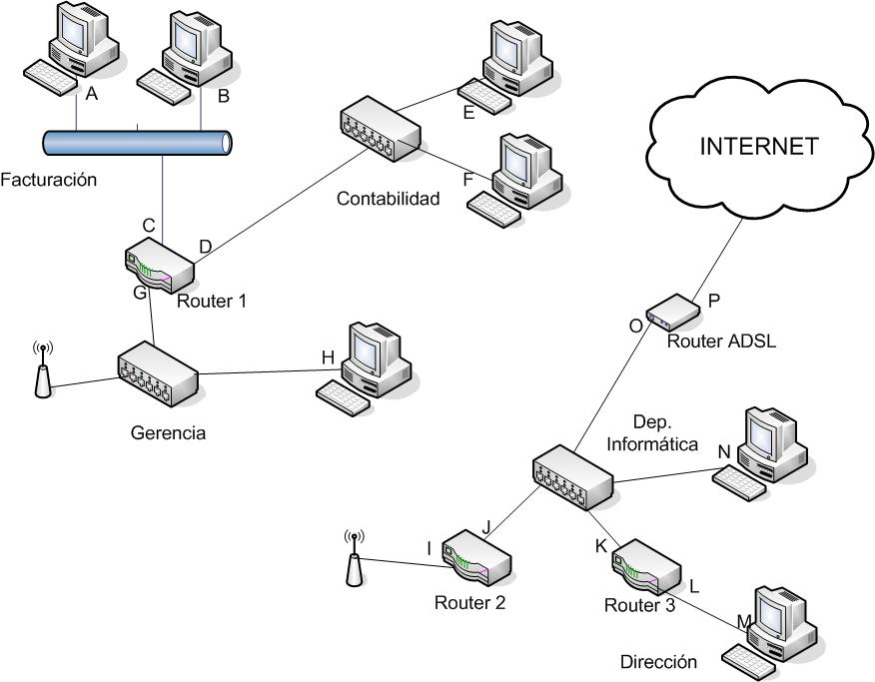

|  |  |  |
| --- | --- | --- |
|  | IP | MASCARA |
| A | 192.168.6.10 | /24 |
| B | 192.168.6.11 | /24 |
| C | 192.168.6.1 | /24 |
| D | 192.168.7.1 | /24 |
| E | 192.168.7.89 | /24 |
| F | 192.168.7.100 | /24 |
| G | 192.168.8.1 | /24 |
| H | 192.168.8.20 | /24 |
| I | 192.168.8.2 | /24 |
| J | 192.168.9.1 | /24 |
| K | 192.168.9.2 | /24 |
| L | 192.168.10.1 | /24 |
| M | 192.168.10.2 | /24 |
| N | 192.168.9.77 | /24 |
| O | 192.168.9.99 | /24 |
| P | 64.50.64.80 | /24 |

2. Completa la siguiente tabla:

|  |  |  |
| --- | --- | --- |
| RED | Dirección de red | Máscara |
| Contabilidad | 192.168.7.100 | /24 |
| Facturación | 192.168.6.100 | /24 |
| Gerencia | 192.168.8.111 | /24 |
| Dirección | 192.168.10.123 | /24 |
| Departamento Informática | 192.168.9.143 | /24 |

3. Completa las tablas de routeo de los routers, para que todos se comuniquen con todos:

Router 1

|  |  |  |  |
| --- | --- | --- | --- |
| Destino | Mascara | Gateway | Interfaz |
| 192.168.6.0 | /24 | - | 192.168.9.99 |
| 192.168.8.0 | /24 | - | 192.168.9.99 |
| 192.168.7.0 | /24 | - | 192.168.9.99 |
| 0.0.0.0 | /0 | 192.168.8.1 | 192.168.8.2 |
| 192.168.9.0 | /24 | 192.168.8.2 | 192.168.9.99 |
| 192.168.10.0 | /24 | 192.168.8.2 | 192.168.9.99 |
|  |  |  | 192.168.9.99 |

Router 2

|  |  |  |  |
| --- | --- | --- | --- |
| Destino | Mascara | Gateway | Interfaz |
| 192.168.9.0 | /24 | - | 192.168.9.99 |
| 192.168.8.0 | /24 | - | 192.168.9.99 |
| 0.0.0.0 | /0 | 192.168.9.1 | 192.168.9.99 |
| 192.168.7.0 | /24 | 192.168.6.1 | 192.168.9.99 |
| 192.168.6.0 | /24 | 192.168.7.1 | 192.168.9.99 |
| 192.168.10.0 | /24 | 192.168.9.1 | 192.168.9.99 |
|  |  |  |  |

Router 3

|  |  |  |  |
| --- | --- | --- | --- |
| Destino | Mascara | Gateway | Interfaz |
| 192.168.10.0 | /24 | - | 192.168.9.99 |
| 192.168.9.0 | /24 | - | 192.168.9.99 |
| 0.0.0.0 | /0 | 192.168.9.2 | 192.168.9.99 |
| 192.168.7.0 | /24 | 192.168.9.1 | 192.168.9.99 |
| 192.168.6.0 | /24 | 192.168.9.1 | 192.168.9.99 |
| 192.168.8.0 | /24 | 192.168.9.1 | 192.168.9.99 |
|  |  |  |  |

Router ADSL

|  |  |  |  |
| --- | --- | --- | --- |
| Destino | Mascara | Gateway | Interfaz |
| 0.0.0.0 | /0 | ISP | 64.50.64.80 |
| 192.168.9.0 | /24 | - | 192.168.9.99 |
| 192.168.10.0 | /24 | 192.168.9.2 | 192.168.9.99 |
| 192.168.8.0 | /24 | 192.168.8.1 | 192.168.9.2 |
| 192.168.7.0 | /24 | 192.168.8.1 | 192.168.9.2 |
| 192.168.6.0 | /24 | 192.168.8.1 | 192.168.9.2 |